Three dimensional geometry developed accordance to Einsteins field equations. It is useful in several branches of science like it is useful in Electromagnetism. It is used in computer alogorothms to construct 3D models that can be interactively experinced in virtual reality fashion. These models are used for single view metrology. 3-D Geometry as carrier of information about time by Einstein. 3-D Geometry is extensively used in quantum & black hole theory.
Section Formula:
(1) Integral division: If R(x, y, z) is point dividing join of P(x₁, y₁, z₁) & Q(x₂, y₂, z₃) in ratio of m : n.
Then, x = 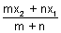, y = 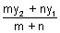, z = 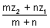
(2) External division: Coordinates of point R which divides join of P(x₁, y₁, z₁) & Q(x₂, y₂, z₂) externally in ratio m : n are 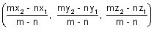
Illustration: Show that plane ax + by + cz + d = 0 divides line joining (x₁, y₁, z₁) & (x₂, y₂, z₂) in ratio of 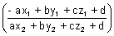
Ans: Let plane ax + by + cz + d = 0 divides line joining (x₁, y₁, z₁) & (x₂, y₂, z₂) in ratio K : 1
Coordinates of P
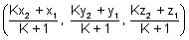
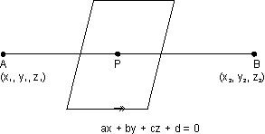
must satisfy eq. of plane.
ax + by + cz + d = 0
[Dumb Question: Why coordinates of P satisfy eq. of plane ?
Ans: Point P lies in the plane so, it satisfy eq. of plane.]
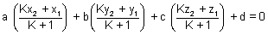
a(Kx₂ + x₁) + b(Ky₂ + y₁) + c(Kz₂ + z₁) + d(K + 1) = 0
K(ax₂ + by₂ + cz₂ + d) + (ax₁ + by₁ + cz₁ + d) = 0
K = - 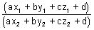
Direction Cosines:
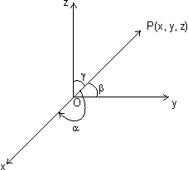
Let is a vector , , inclination with x, y & z-axis respectively. Then cos, cos & cos are direction cosines of . They denoted by
, , direction angles.
& lies 0 , ,
Note: (i) Direction cosines of x-axis are (1, 0, 0)
Direction cosines of y-axis are (0, 1, 0)
Direction cosines of z-axis are (0, 0, 1)
(ii) Suppose OP be any line through origin O which has direction l, m, n
(r cos, r cos, r cos) where OP = r
coordinates of P are (r cos, r cos, r cos)
or x = lr, y = mr, z = nr
(iii) l² + m² + n² = 1
Proof: || = || =
||² = x² + y² + z² = l²||² + m²||² + n²||²
l² + m² + n² = 1
(iv)
Direction ratios: Suppose l, m, & n are direction cosines of vector & a, b, c are no.s such that a, b, c are proportional to l, m, n. These a, b, c are c/d direction ratios.
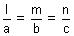= k
Suppose a, b, c are direction ratios of vector having direction cosines l, m, n. Then,
= l = a, m = b, n = c
l² + m² + n² = 1
a²² + b²² + c²² = 1 = ± 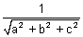
l = ± 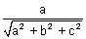, m = ± 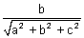, n = ± 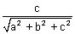
Note: (i) If having direction cosines l, m, n. Then, l = , m = , n =
(ii) Direction ratios of line joining two given points
(x₁, y₁, z₁) & (x₂, y₂, z₂) is (x₂ - x₁, y₂ - y₁, z₂ - z₁)
(iii) If direction ratio's of are a, b, c
= 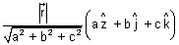
(iv) Projection of segment joining points P(x₁, y₁, z₁) and Q(x₂, y₂, z₂) on a line with direction cosines l, m, n, is:
(x₂ - x₁)l + (y₂ - y₁)m + (z₂ - z₁)n
Illustration: If a line makes angles , & with coordinate axes, prove that sin² + sin² + sin² = 2
Ans: Line is making , & with coordinate axes.
Then, direction cosines are l = cos, m = cos & n = cos.
But l² + m² + n² = 1
cos² + cos² + cos² = 1
1 - sin² + 1 - sin² + 1 - cos² = 1
sin² + sin² + sin² = 2
Angle b/w two vectors in terms of direction cosines & direction ratios:
(i) Suppose & are two vectors having d.c's l₁, m₁, n₁ & l₂, m₂, n₂ respectively. Then,
&
Dumb Question: How ?
Ans: 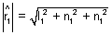
But l₁² + m₁² + n₁² = 1
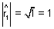
So,
cos = 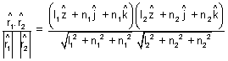
cos = l₁l₂ + m₁m₂ + n₁n₂
(ii) IF a₁, b₁, c₁ and a₂, b₂, c₂ are d.r.s of & . Then
&
cos = 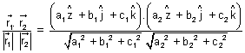
cos = 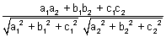
Note: (i) If two lines are then,
cos = 0 or l₁l₂ + m₁m₂ + c₁c₂ = 0
or a₁a₂ + b₁b₂ + c₁c₂ = 0
(ii) If two lines are || then
cos = 1 or 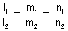
or 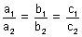
Illustration: Find angle b/w lines whose direction cosines are 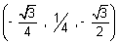 & 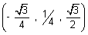.
Ans: Let be angle
cos = l₁l₂ + m₁m₂ + n₁n₂
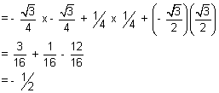
cos = - = 120⁰
Straight line:
Vectorial eq. of line:
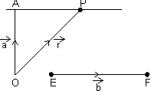
Let a line passing through a point of P.V. & || to given line EF().
Then, eq. of line
Proof: Let P be any point on line AP & its P.V. is
Then, = = (By law)
Dumb Question: Why = ?
Ans: Since is || to EF of P.V.
So, =
Note: Eq. of line through origin & || to is =
Cartesion eq. of straight line:
Passing through point & parallel to given vector .
Let line is passing through A(x₁, y₁, z₁) & || to EF whose d.r.'s are a, b, c.
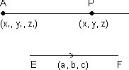
d.r.'s of AP = (x - x₁, y - y₁, z - z₁)
d.r.'s of EF = (a, b, c)
Since EF || AP, then,
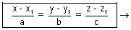b Eq. of line in parametric form.
Illustration: Find eq. of line || to & passing through pt.(1, 2, 3) ?
Ans: A(1, 2, 3) =
eq. of line passing through & || to
= () + ()
Vector eq. of line passing through two given points:
Vector eq. of line passing through two points whose P.V. S & is:
= + ( - )
Proof: is collinear with
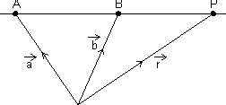
=
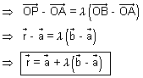
Cartesian form:
Eq. of line passing through (x₁, y₁, z₁) & (x₂, y², z₂)
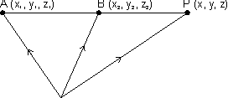
D.R.'s of AB = (x₂ - x₁, y₂ - y₁, z₂ - z₁)
D.R.'s of AP = (x - x₁, y - y₁, z - z₁)
Since AB || AP
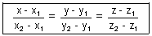
Illustration: Find cartesian eq. of line are 6x + 2 = 3y - 1 = 2z + 2. Find its direction ratios.
Ans: 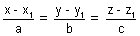 is cartesion eq. of line
6x + 2 = 3y - 1 = 2z + 2
6(x + ) = 3(y - ) = 2(z + 1)
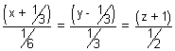
on comparing a = , b = , c =
Angle b/w Two lines:
=
Angle b/w two lines cos = 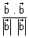
If
=
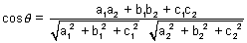
Condition for perpendicularity:
. = 0 a₁a₂ + b₁b₂ + c₁c₂
Condition for parallelism:
Dumb Question: Why angle between pair of lines
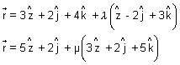
Ans: &
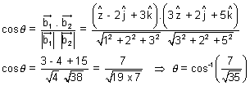
Perpendicular distance of point froma line:
(a) Castesian form:
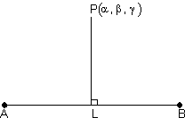
Suppose 'L' is foot of line of .
Since L lies on line AB so,
coordinate of L is
=
i.e. L(x₁ + a, y₁ + b, z₁ + c)
direction ratios of PL are:
(x₁ + a - , y₁ + b - , z₁ + c - )
also direction ratios of AB are (a, b, c)
Since PL AB
a(x₁ + a - ) + b(b - ) + c(z₁ + c - ) = 0
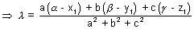

Vector Form:
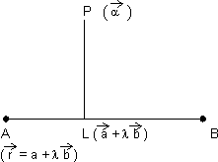
Since L lies on line AB
P.V. of L = P.V. of line AB
= +
dr's of
Since
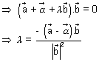
P.V. of L is +
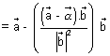
Reflection of point in straight line:
Castesian Form:
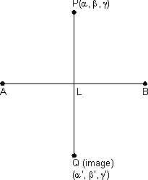
From above, we get coordinate of L(foot of )
But L is mid point of PQ
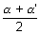= x₁+ a, 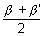= y₁ + b, 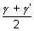= z₁ + c
' = 2(x₁ + a) - , ' = 2(y₁ + b) - , ' = 2(z₁ + c) -
Vector Form:
From above, we get
P.V. of L, +
Let P.V. of Q is 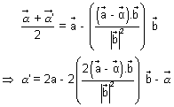
Since L is mid point of PQ
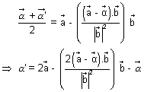
Illustration: Find reflection of point P(2, 3, 1) in line 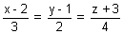
Ans:
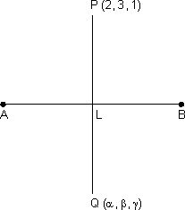
Since L lies on line AB
coordinate of L (3 + 2, 2 + 1, 4 - 3)
DR's of PL are
= (3 + 2 - 2, 2 + 1 - 3, 4 - 3 - 1)
= (3, 2 - 2, 4 - 4)
DR's of AB are (3, 2, 4)
Since PL AB
3(3) + 2(2 - 2) + 4(4 - 4) = 0
9 + 4 - 4 + 16 - 16 = 0
29 = 20 =
Since L is mid point of PQ
So, 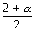= 3 + 2, 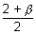= 2 + 1, 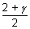= 4 - 3
= (6 + 4 - 2), = (4 + 2 - 3), = 8 - 6 - 1
= 6 + 2, = 4 - 1, = 8 - 7
where =
Skew lines: Those lines which do not lies in same plane.
Shortest distence b/w two skew lines:
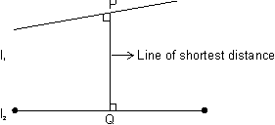
The line which is to both line l₁ & l₂ are c/d line of shortest distance.
Vector Form:
Let l₁ & l₂ are:
& respectively.
Since is to both l₁ & l₂ which are parallel to &
is || to x
Let be unit vector along , then = ± 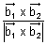
PQ = Projection of on
= .
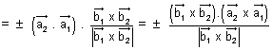
Dumb Question: How PQ = Projection on ?
Ans: Form fig., it is clear that PQ is projection of on .
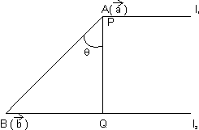
PQ = 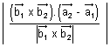
Cartesian form: Two skew lines
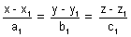 & 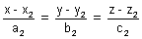
Shortest distance :
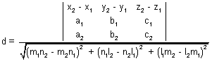
Condition for lines to intersect:
Two lines intersects if shortest distance = 0
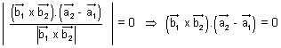
or 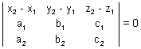
Shortest distance b/w parallel line:
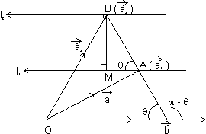
Let l₁ & l₂ are
respectively
& BM is shortest distance b/w l₁ & l₂
sin = BM = AB sin = || sin
| x | = || || sin( - )
= || || sin = (|| sin) || =
Dumb Question: Why we have taken sin( - ) ?
Ans:
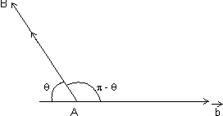
Since direction of vector is opposite to || lines. So, we have taken ( - ) instead of
BM = 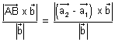
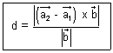
Illustration: Find shortest distance b/w lines:
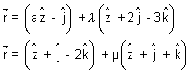
Ans: 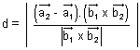
On comparing
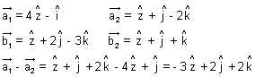
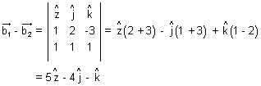
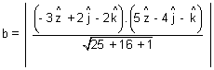
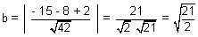
Plane:
(i) Eq. of plane passing through a given point (x₁, y₁, z₁) is:
a(x - x₁) + b(y - y₁) + c(z - z₁) = 0 where a, b, c constants.
Proof: General eq. of plane is ax + by + cz + d = 0 ....................................... (i)
It is passes through (x₁, y₁, z₁)
ax₁ + by₁ + cz₁ + d = 0 ............................................. (ii)
By (i) - (ii), we get
a(x - x₁) + b(y - y₁) + c(z - z₁) = 0
Intercept form of a plane:
eq. of plane of intercepting lengths a, b & c with x, y & z-axis respectively is,
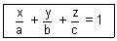
Illustration: A variable plane moves in such a way that sum of reciprocals of its intercepts on 3 coordinate axes is constant. Show that plane passes through fixed point.
Ans: Let eq. of plane is 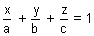. Then, intercepts of plane with axes are:
A(a, 0, 0), B(0, b, 0), c(0, 0, c)
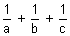 = constant (k) (given)
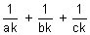= 1 & comparing with fixed point
x = , y = , z =
This shows plane passes through fixed point (, , )
Vector eq. of plane passing through a given point & normal to given vector:
VEctor eq. of plane passing through u point of P.V. & normal to vector is ( - ). = 0
Dumb Question: What is normal to vector ?
Ans: Plane normal to vector means the every line in plane is to that given vector.
Proof: Let plane passes through A() & normal to vector & be P.V. of every point 'P' on palne.
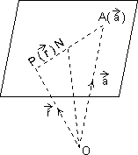
Since lies in plane & is normal to plane.
. = 0
( - ). = 0 ( = - )
eq. of plane ( - ). = 0
Eq. of plane in normal form:
Vector eq. of plane normal to unit vector & at O distance d from origin is . = d.
Proof:
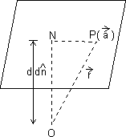
ON is to plane such that & =
Since . = 0
( - ). = 0
( - d).d = 0 .d - d². = 0
d(.) - d² = 0 . = d
eq. of plane is . = d
Cartesian Form: Let l, m, n be d.r.'s of normal to given plane & P is length of from origin to plane, then eq. of plane is lx + my + nz = P.

Dumb Question: How this lx + my + nz = P is eq. of plane ?
Ans: Since . = P = d is eq. of plane
&
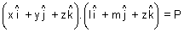
lx + my + nz = P
Illustration: Find vector eq. of plane which is at a distance of 8 units from origin & which is normal to vector .
Ans: d = 8 & =
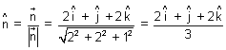
eq. of plane is, . = d
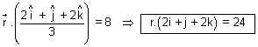
Eq. of plane passing through 3 given points:
Eq. of plane passing through three points A, B, C having P.V.'s , , respectivelt.
Let be P>V> of any point P is the plane.
So, vectors,
= - , = - , = - are coplanar
Hence, .( x ) = 0
( - ).{( - ) x ( - )} = 0
( - ).( x - x - x - x ) = 0
( - ).( x + x + x ) = 0
.( x + x + x ) = .( x ) + .( x ) + .( x )
[] + [] + [] = []
Note: If P is length of from origin on this plane,
then P = 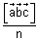 n = | x + x + x |
Eq. of plane that passes through a point A with position vector & is || to given vectors & :
Derivation:
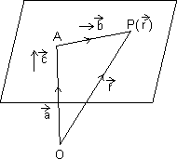
Let be P.V. of any point P in plane
Then, = - = -
Sincen x are || to plane.
So, vector - , & are coplanar
( - ).( x ) = 0
.( x ) = .( x )
[] = []
Cartesian form: Eq. of plane passing through a point (x₁, y₁, z₁) & || to two lines having direction ratios (₁, ₁, ₁) & (₂, ₂, ₂) is:
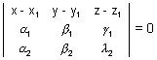
Illustration: Find eq. of plane passing through points
P(1, 1, 1), Q(3, -1, 2), R(-3, 5, -4).
Ans: Let eq. of plane is ax + by + cz + d = 0
It passes through P(1, 1, 1). So,
eq. of plane
a(x - 1) + b(y - 1) + c(z - 1) = 0 .......................................... (i)
But it also passes through Q & R
2a - 2b + c = 0] x (- 2)
- 4a + 4b - 5c = 0
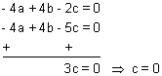
Similarly a = 6, b = 6
Putting these in eq. (i)
We get, 6(x - 1) + 6(y - 1) = 0 x + y = 2
Angle b/w two planes:
. = d₁ . = d₂ are two planers, then
cos = 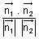
Note: Angle b/w planes is defined as angle b/w their normals.
Cartesion Form: Let planes are a₁x + b₁y + c₁z + d₁ = 0 & a₂x + b₂y + c₂z + d₂ = 0
cos = 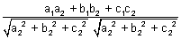
Condition for :
. = 0
or a₁a₂ + b₁b₂ + c₁c₂ = 0
Condition for parallelism:
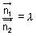 or 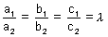
Angle b/w line & a plane:
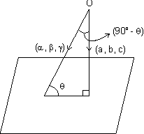
If , , be direction ratios of line & ax + by + cz + d = 0 be eq. of plane in which normal has d.r's a, b, c. Q is angle b/w line & plane.
cos(90⁰ - ) = 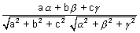
Vector form: If is angle b/w line & plane . = d
sin = 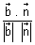
Illustration: Find angle b/w line 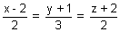& 3x + 2y - 2z + 3 = 0.
Ans: D.r's of line are 2, 3, 2 & d.r's of normal to plane are 3, 2, - 2
sin = 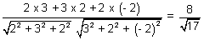
= sin⁻¹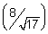
Eq. of plane passing through the Line of Intersection of planes
a₁x + b₁y + c₁z + d₁ = 0 & a₂x + b₂y + c₂z + d₂ = 0 is
(a₁x + b₁y + c₁z + d₁) + k(a₂x + b₂y + c₂z + d₂) = 0
Dumb Question: How this eq. is that of required plane ?
Ans: Let P(, , ) be point on line of intersection of two planes. So, it lies on both the planes.
i.e. a₁ + b₁ + c₁ + d₁ = 0
& a₂ + b₂ + c₂ + d₂ = 0
So, point P(, , ) should lie on required plane.
i.e. (a₁ + b₁ + c₁ + d₁) + k(a₂ + b₂ + c₂ + d₂ ) = 0
P(, , ) lies on. plane (a₁x + b₁y + c₁z + d₁) + k(a₂x + b₂y + c₂z + d₂) = 0
Vector Form:
. = d₁ & . = d₂
So, eq. of required plane is (. - d₁) + k(. - d₂) = 0
Illustration: Find eq. of plane constaining line of intersection of plane x - y + z + 7 = 0 and x + 3y + 2z + 5 = 0 & passing through (1, 2, 2).
Ans: Eq. of plane through line of intersection of given planes is,
(x - y + z + 7) + (x + 3y + 2z + 5) = 0 ....................................... (i)
It passes through (1, 2, 3)
(1 - 2 + 2 + 7) + (1 + 3 x 2 + 2 x 2 + 5) = 0
8 + (7 + 4 + 5) = 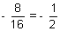
Putting = - in eq. (i)
We get,
(x - y + z + 7) + (- )(x + 3y + 2z + 5) = 0
2x - 2y + 2z + 14 - x - 3y - 2z - 5 = 0
x - 5y + 9 = 0
Two sides of plane:
If ax + by + cz + d = 0 be a plane then points (x₁, y₁, z₁) & (x₂, y₂, z₂) are points lies on
Same side if 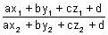> 0 & opposite side if < 0
Distance of point from a plne:
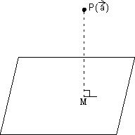
Length of from a point having P.V. to plane . = d is given by
P = 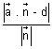
Proof: PM is length of from P to plane. Since line PM passes through P() & || to vector which is normal to plane.
eq. of line = x ....................................................... (i)
Since point M is intersection of line & plane. So, it lies on line as well as plane
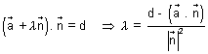
Putting in eq. (i)
= + 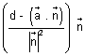
= P.V. of M - P.V. of P = + -
Dumb Question: How P.V. of M is + 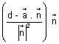
Ans: M lies on line as well as plane. On solving value of for line eq. We get P.V. of M.
So, this is P.V. of M
PM = || = 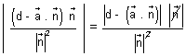
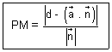
Cartesian Form: Length of from point P(x₁, y₁, z₁) to plane ax + by + cz + d = 0, Then eq. of PM is
= r
[Dumb Question: How this eq. of PM comes ?
Ans: It is passes through point (x₁, y₁, z₁) & || to normal of plane so, we get this eq.]
Coordinates of any point on PM are
(x₁ + ar, y₁ + br, z₁ + cr)
But this also coordinate of M & M also lies on plane
a(x₁ + ar) + b(y₁ + br) + c(z₁ + cr) + d = 0
i.e. r = - 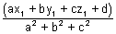
PM =
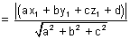
Distance b/w parallel planes:
Distance b/w || planes is difference of length of from origin to two planes.
Let ax + by + cz + d₁ = 0 & ax + by + cz + d₂ = 0
D = 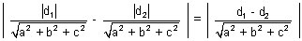
Vector Form: . = d₁ & . = ₂
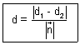
Illustion: Find distance b/w parallel planes
x + 2y + 2z + 2 = 0 & 2x + 4y + 4z + 3 = 0
Ans: Distance b/w ax + by + cz + d₁ = 0 & ax + by + cz + d₂ = 0 is
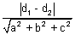
x + 2y + 2z + 2 = 0 & x + 2y + 2z + = 0
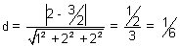

Equation of planes Bisecting Angle b/w Two planes:
Eq. of planes bisceting angle b/w planes, a₁x + b₁y + c₁z + d₁ = 0 and a₂x + b₂y + c₂z + d₂ = 0 is,
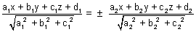
Proof: Let P(x, y, z) be point on plane bisecting angle b/w two planes 7 PL & PM is length of from P to planes.
By property of angle bisector.
PL = PM
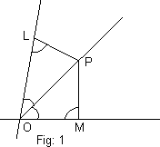
[Dumb Question: How PL = PM ?
Ans: In fig 1. OPL & OPM are congruent by AAA symmetry. So, all sides are equal.
So, PL = PM.]
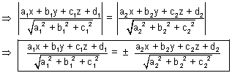
Note: (i) Eq. of bisector of angle b/w two planes containing origin is
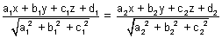
(ii) Bisector of acute & obtuse angles b/w:
Let a₁x + b₁y + c₁z + d₁ = 0
& a₂x + b₂y + c₂z + d₂ = 0 where d₁, d₂ > 0
(a) If a₁a₂ + b₁b₂ + c₁c₂ > 0, origin lies in obtuse angle bisector & eq. of bisector of acute angle is
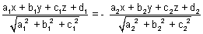
(b) If a₁a₂ + b₁b₂ + c₁c₂ < 0, origin lies in atute angle bisector & eq. of acute angle bisector is
Illustration: Find eq. of bisector planes of angle b/w planes 2x + y - 2z + 3 = 0 & 3x + 2y - 6z + 8 = 0 specify obtuse & acute angle bisectors.
Ans: 2x + y - 2z + 3 = 0 & 3x + 2y - 6z + 8 = 0 where d₁, d₂ > 0
Now a₁a₂ + b₁b₂ + c₁c₂ = 2 x 3 + 1 x 2 + 2 x 6 > 0
...................................... (i)
(i) is obtuse angle bisector plane
& ................................................ (ii)
(ii) is acute angle bisector plane.
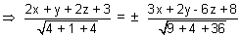
14x + 7y - 14z + 21 = ± 9x + 6y - 18z + 24
For obtuse angle bisector plane, Take -ve sign
5x + y + 4z - 3 = 0
Intersection of line & plane:
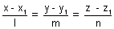= r & plane ax + by + cz + d = 0
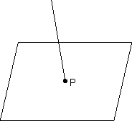
Let P be point of intersection coordinate of P(x₁ + lr, y₁ + mr, z₁ + nr)
But it satisfy eq. of plane.
a(x₁ + lr) + b(y₁ + mr) + c(z₁ + nr)
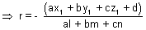
Condition for line to be || to a plane:
be || to plane ax + by + cz + d = 0
if al + bm + cm = 0 or sin = 0
Condition for a line to lie in the plane:
line lie in plane ax + by + cz + d = 0
if al + bm + cn = 0 & ax₁ + by₁ + cz₁ + d = 0
Dumb Question: How line be || to plane if al + bm + cn = 0 ?
Ans: If is angle b/w line & plane, then
sin = 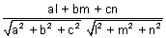 [Previously desired]
line is || to plane if sin = 0 or al + bm + cn = 0
Sphere:
Equation of sphere whose centre is & radius is a:
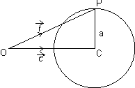
In OPC,
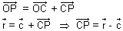
| - | = CP = a (radius)
| - |² = a² ( - ).( - ) = A²
R² - 2. + c² = a² r² - 2. + (c² - a²) = 0
Cartesian Form:
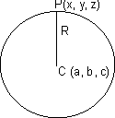
From Fig. CP = R
CP² = R²
By distance formula.
(x - a)² + (y - b)² + (z - c)² = R²
GEneral eq. of sphere:
x² + y² + z² + 2ux + 2vy + 2wz + d = 0 is a sphere with centre (- u, - v, - w) &
radius =
Illustration: Find centre & radius of sphere 2x² + 2y² + 2z² - 2x - 4y + 2z + 3 = 0
Ans: 2x² + 2y² + 2z² - 2x - 4y + 2z + 3 = 0
or x² + y² + z² - x - 2y + z + = 0
centre is (- coeff. of x, - coeff. of y, - coeff. of z)
centre (, 1, - )
radius = 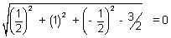
Thus sphere is point circle.
Diameter form of Eq. of sphere:
Vector Form: Suppose & be P.V of extremities A & B of diameter AB of sphere. Let be P.V. of any point P on sphere. Then,
= - & B = -
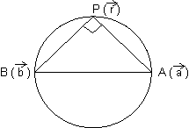
Since, diameter of sphere subtends a right at any point of sphere.
APB = . = 0
( - ).( - ) = 0
||² - ( + ). + . = 0
or AP² + BP² = AB²
| - |² + | - | = | - |²
Cartesian Form: If A(x₁, y₁, z₁) & B(x₂, y₂, z₂) are extremities of diameter then, eq. of sphere is (x - x₁)(x - x₂) + (y - y₁)(y - y₂) + (z - z₁)(z - z₂) = 0
Section of sphere by plane:
If sphere is intersection by a plane. We get circle by intersection.
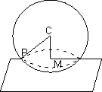
PM is radius of circle
PM =
Condition of Tangency of plane to a sphere:
Vector Form: Plane . = d touches sphere | - | = R
if 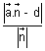= R
Dumb Question: Why = R ?
Ans: A plane touches to sphere if distaqnce from centre of sphere is equal to radius.
Cartesian Form: Plane ln + my + nz = p touches (ul + vm + wn + p)² = (l² + m² + n²)(u² + v² + w² -d)
Illustration: Find eq. of sphere whose centre has P.V. & which touches plane .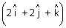 = 10
Ans: Center =
It touches plane . = 10
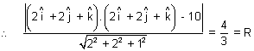
eq. of sphere | - | =
Easy Type
Q.1. Find ratio in which 2x + 3y + 5z = 1 divides line joining the points (1, 0, 2) & (1, 2, 5)
Ans: Let the ratio be k = 1 at point P
Then, P = 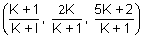must satisfy 2x + 3y + 5z = 1
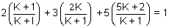
2(K + 1) + 6K + 25K + 10 = K + 1 K + 1 + 6K + 25K + 10 = 0
32K + 11 = 0 K =
Thus line divides externally in rstio of 11:32

Q.2. What are direction cosines of a line which is equally inclined to axes ?
Ans: If , , are angles, if line is equally inclined
= =
l² + m² + n² cos² + cos² + cos² = 1
3 cos² = 1 cos = ± = cos = cos
d.c's arw (, , ) or (- , - , - )
Q.3. Find direction cosines of line which is to lines with d.r (1, -2, -2) & (0, 2, 1)
Ans: Let l, m, n be d.c's line 1 to given line, d.c's are proportional to d.r's
d.c'r of lines are (, - 2, - 2) & (0, 2µ, µ)
Since line is to given lines
l + (- 2m) + (- 2n) = 0 l - 2m - 2n = 0
& 0 + 2mµ + nµ = 0 2m + n = 0
By cross multiplication,
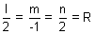
l = 2R, m = - R & n = 2R
l² + m² + n² = 1
4R² + R² + 4R² = 1 9R² = 1 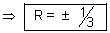
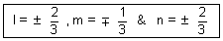
Q.4. Prove that line x = ay + b, z = cy + d & x = a'y + b', z = c'y + d' are if aa' + cc' + 1 = 0
Ans: Ist line is x = ay + b, z = cy + d
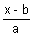 = y, 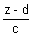= y = 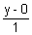= ................................ (i)
and IInd line 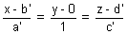................................................. (ii)
These lines are if
aa' + |x| + cc' = 0 aa' + cc' + 1 = 0
Dumb Question: For what value of k, lines 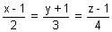 & 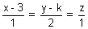intersect?
Ans: =
and = µ
Since these lines have point of intersection in common. then
(2 + 1, 3 - 1, 4 + 1) = (µ + 3, 2µ + k, µ)
or 2 + 1 = µ + 3 ....... (i), 3 - 1 = 2µ + k ....... (ii) & 4 + 1 = µ ....... (iii)
on solving (i) & (iii), we get = - 3/2 & µ = - 5
Substituting in (ii)
- - 1 = - 10 + k k =
Q.6. Show that points and are equidistant from plane .() + 9 = 0
Ans: .() = - 9
length of from ()
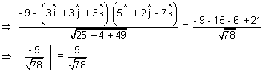
So, length of is equal.
Q.7. Find the point in which the plane; = ( - ) + m( + + ) + n( + - ) is cut by line through point 2 + 3 & parallel to .
Ans: eq. of line through point 2 + 3 & || to
= (2 + 3) +
Since line cuts plane
For one point,
(2 + 3) + = - + m( + + ) + n( + - )
Equating coeff. of , & on both side, we get
m + n = 1, m - n = 4, - m + n =
m = , n = & = - 4
P.V. of required point is: 2 + 3 - 4
Q.8. Show that line of intersection of planes .() = 0 & .() = 0 is equally inclined to & .
Ans: Note: Line of intersection of two planes will be to normals to the planes. Hence it is || to vector
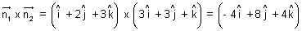
Now,
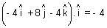
&
So, line is equally inclined to &
Q.9. Projection of line segment on 3 axes 4, 5 & 13 respectively. Find length & direction cosines of line segment.
Ans:
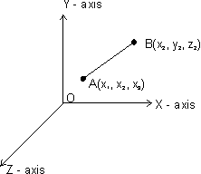
= (x₂ - x₁) + (y₂ - y₁) + (z₂ - z₁)
Projection of on x-axis
= . = (x₂ - x₁) = 4
Projection of on y-axis
= . = (y₂ - y₁) = 5
Projection of on z-axis
= . = (z₂ - z₁) = 13
Length of AB =
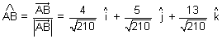
d.r's = 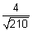, 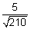& 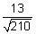
Q.10. Find locus of mid point of chords of sphere r² - 2. + k = 0 if chords being drawn || to vector .
Ans: r² - 2. + k = 0 is sphere of centre chord AB || .
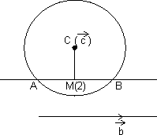
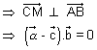
locus of M is ( - ). = 0
. = . represents a plane.
Dumb Question: Why is same as ?
Ans: Since || . So, if is . So, it will also to .
Medium Type
Q.1. If a variable plane forms a tetrahedron of constant volume 27k³ with coordinate planes, find locus of centroid of tetrahedron.
Ans: sLet variable plane cuts coordinate axes at A(a, 0, 0), B(0, b, 0), C(0, 0, c)
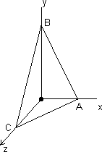
Then, eq. of plane will be
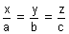 = 1
Let P, , ) be centroid of terahedron OABC,
then, = , = , =
[Dumb Question: How this centroid tetrahedron OABC comes = , = , = ?
Ans: Centroid of tetrahedrold
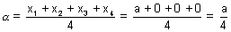
where (x₁, y₁, z₁), (x₂, y₂, z₂), (x₃, y₃, z₃) & (x₄, y₄, z₄) are coordinate of tetrahedron.]
Volume of tetrahedron = (Area of AOB).OC
27k³ = (ab)c =
27k³ = 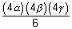
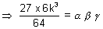
Required locus of P(, , ) is
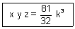
Q.2. Find vector eq. of straight line passing through intersection of plane
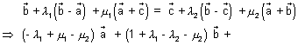
, , are non coplanar vectors.
Ans: At points of intersection of two planes.
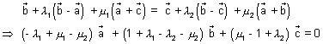
Since , , are non coplanar, then
- ₁ + µ₁ - µ₂ = 0, 1 + ₁ - ₂ - µ₂ = 0, µ₁ - 1 + ₂ = 0

On solving, we get ₁ = 0 & µ₁ = µ₂
= + ₁( - ) + µ₁( + )
Since ₁ = 0
= + µ₁( + ) is required eq. of straight line.
Q.3. Prove that three lines from O with direction cosines l₁, m₁, n₁; l₂, m₂, n₂; l₃, m₃, n₃ are coplaner if
l₁(m₂n₃ - n₂m₃) + m₁(n₂l₃ - l₂n₃) + n₁(l₂m₃ - l₃m₂) = 0
Ans: Note: Three given lines are coplanar if they have common perpendicular. Let d.c's of common be l, m, n
ll₁ + mm₁ + nn₁ = 0 ............................. (i)
ll₂ + mm₂ + nn₂ = 0 ............................. (ii)
ll₃ + mm₃ + nn₃ = 0 ............................. (iii)
Soplving (ii) & (iii) by cross multiplication ......
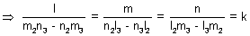
l = k(m₂n₃ - n₂m₃), m = k(n₂l₃ - n₃l₂), n = k(l₂m₃ - l₃m₂)
Substituting in (i), we get
k(m₂n₃ - n₂m₃)l₁ + k(n₂l₃ - n₃l₂)m₁ + k(l₂m₃ - l₃m₂)n₁ = 0
l₁(m₂n₃ - n₂m₃) + m₁(n₂l₃ - n₃l₂) + n₁(l₂m₃ - l₃m₂) = = 0
Q.4. Solve the equation x + y + z =
Ans: x + y + z = .................................. (i)
Taking dot product by x , we get
x.( x ) + y.( x ) + z.( x ) = .( x )
x[] = [] x = 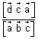
& z = 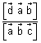
x + y + z =
[] + [] + [] = [] is required solution.
Q.5. If planes x - cy - bz = 0, cx - y + az = 0 & bx + ay - z = 0 pass through a straight line, the find value of a² + b² + c² + 2abc.
Ans: Givem planes are:
x - cy - bz = 0 ............................. (i)
cx - y + az = 0 ............................. (ii)
& bx + ay - z = 0 ............................. (iii)
Eq. of plane passing through line of intersection of plane (i) & (ii) is
(x - cy - bz) + (cx - y + az) = 0
x(1 + c) - (c + ) + z(- b + a) = 0 ............................. (iv)
If plane (iv) & (iii) are same, then,
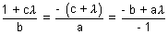
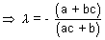 and 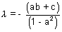
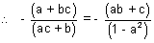
a - a³ + bc - a²bc = a²bc + ac² + ab² + bc
a(2abc + c² + b² + a² - 1) = 0
a² + b² + c² + 2abc = 1
Hard Type
Q.1. Show that distance of a point A() to line = + t is 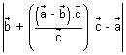which is also equal to 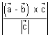.
Ans:
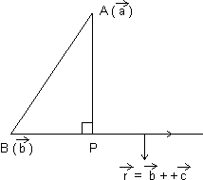
Let P is point on line such that & P.V. of P is = + t
. = 0
( - ).( - ) = 0 ........................... (i)
( + t - ).( + t - ) = 0
( - + t).(t) = 0
t. - t + t² = 0
t( - ) + t²c² = 0
t = 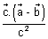..................................... (ii)
From (i) & (ii)
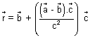
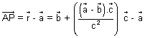
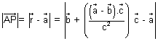 ....................................... (iii)
Also, PA² = AB² - BP² = ||² - ||²
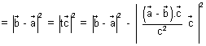
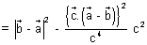
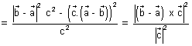 ....................................... (iv)
Dumb Question: How this eq. (iv) const.
Ans: We know that (AB)² -
Q.2. If direction cosines of variable line in two adjacent points be l, m, n & l + l, m + m, n + n show that small anhgle 5 b/w two position is
² = l² + m² + n²
Ans: As we know l² + m² + n² = 1
and (l + l)² + (m + m)² + (n + n)² = 1
l² + (l²) 2ll + m² + (m)² + 2mm + n² + (n)² + 2nn = 1
l² + m² + n² + (l)² + (m)² + (n)² + 2(ll + mm + nn) = 1
(l)² + (m)² + (n)² = - 2(ll + mm + nn) ............................ (i)
is angle b/w two positions.
cos = l(l + l) + m(m + m) + n(n + n)
1 - 2 sin² = 1 + ll + mm + nn ........................................... (ii)
From (i) & (ii)
(l)² + (m)² + (n)² = 4 sin²
4()² = (l)² + (m)² + (n)²
()² = (l)² + (m)² + (n)²
Dumb Question: How sin² is equal to ()² ?
Ans: Since is very small so, is very small
So, sin as 0
So, for approsmation we have taken.
Q.3. Find image of point P(3, 5, 6) in plane 2x + y + z = 0 & find eq. of sphere having point P(3, 5, 6) & its image point of extremities of diameter.
Ans:
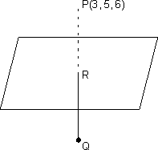
2x + y + z = 0
P(3, 5, 6)
dr's iof normal to plane (i) are 2, 1, 1
Let be image of point P in plane (i)
Eq of P R is,
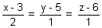 = r
R(2r + 3, r + 5, r + 6)
[Dumb Question: How eq. of line PR come ?
Ans: d.r's of normal to plane is same as d.r's of line PR i.e. 2, 1, 1
So, we get eq. of line PR]
But R lies on (i)
2(2r + 3) +(r + 5) + (r + 6) = 0
6r + 17 = 0 r = -
R 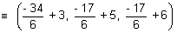
Since R lies mid point of PQ
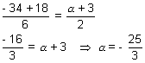
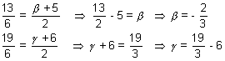
Q = 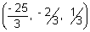
Eq. of sphere when extremities (x₁, y₁, z₁) & (x₂, y₂, z₂) are given:
(x - x₁)(x - x₂) + (y - y₁)(y - y₂) + (z - z₁)(z - z₂) = 0
(x - 3)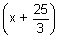 + (y - 5)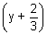 + (z - 6)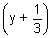 = 0
x² + y² + z² + 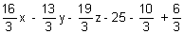= 0
x² + y² + z² + 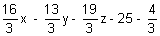= 0
3x² + 3y² + 3z² + 16x - 13y - 19z - 79 = 0
Key words
Direction COsines.
Direction Ratios.
Reflection of a point.
Skew Lines.
Shortest distance.
Intersection of lines.
Normal. FV
Angle bisector.
Tangency of plane to sphere.

